**Power BI Dashboard**

**This interactive Power BI dashboard provides a comprehensive view of sales performance across cities and restaurants in India.**

**Designed for operational and strategic decision-making, it includes dynamic filters, key metrics, and visual insights.**

**Project Summary**

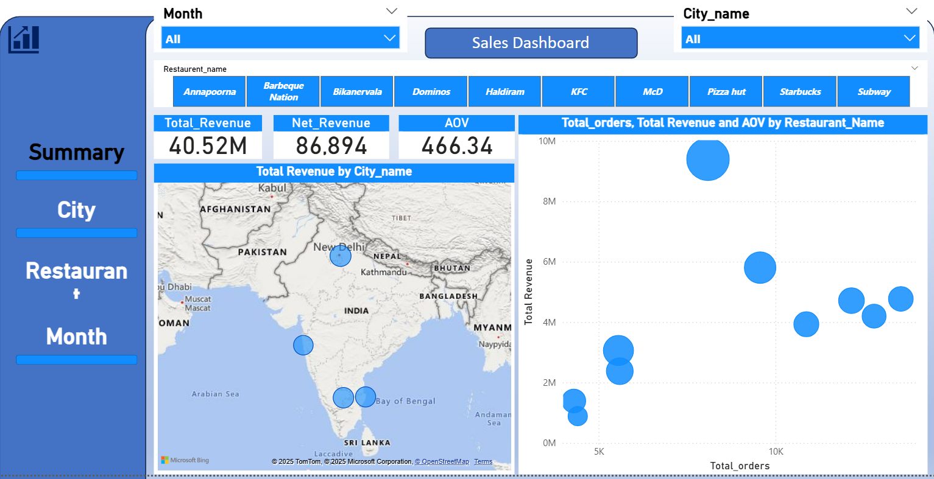

**City Wise**

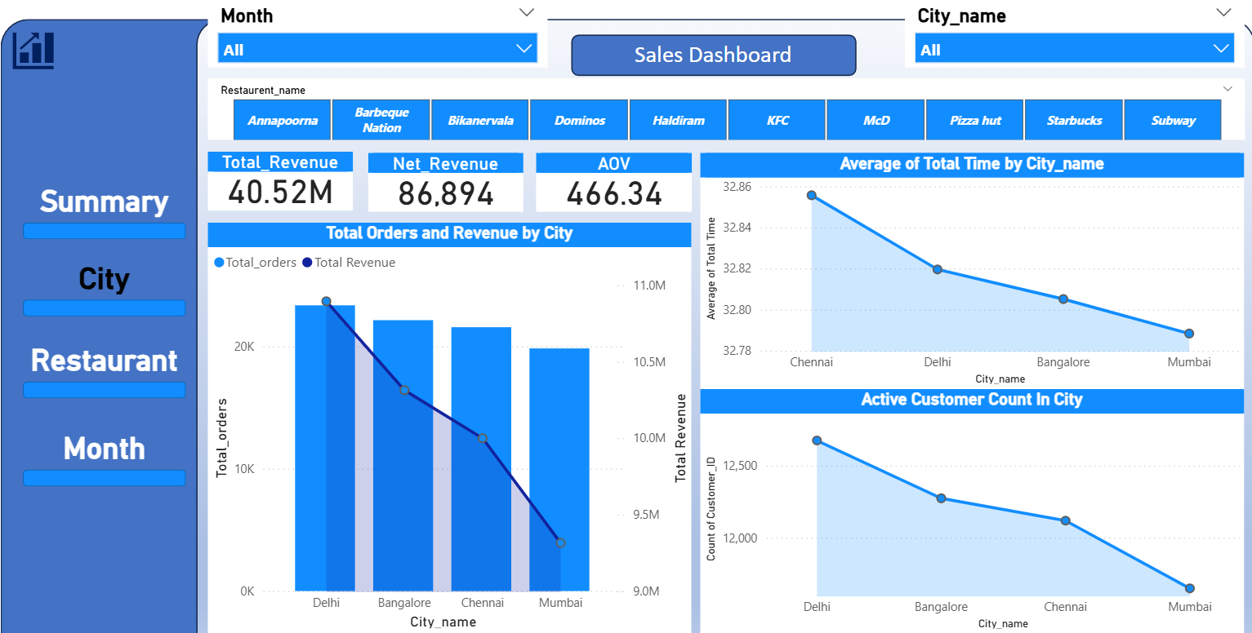

**Restaurant Wise**

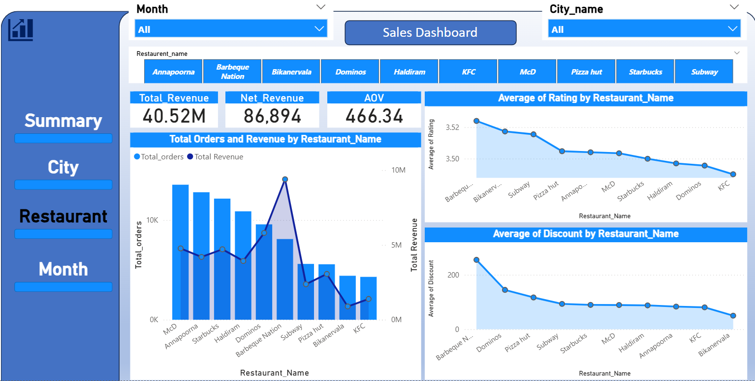

**Month Wise**

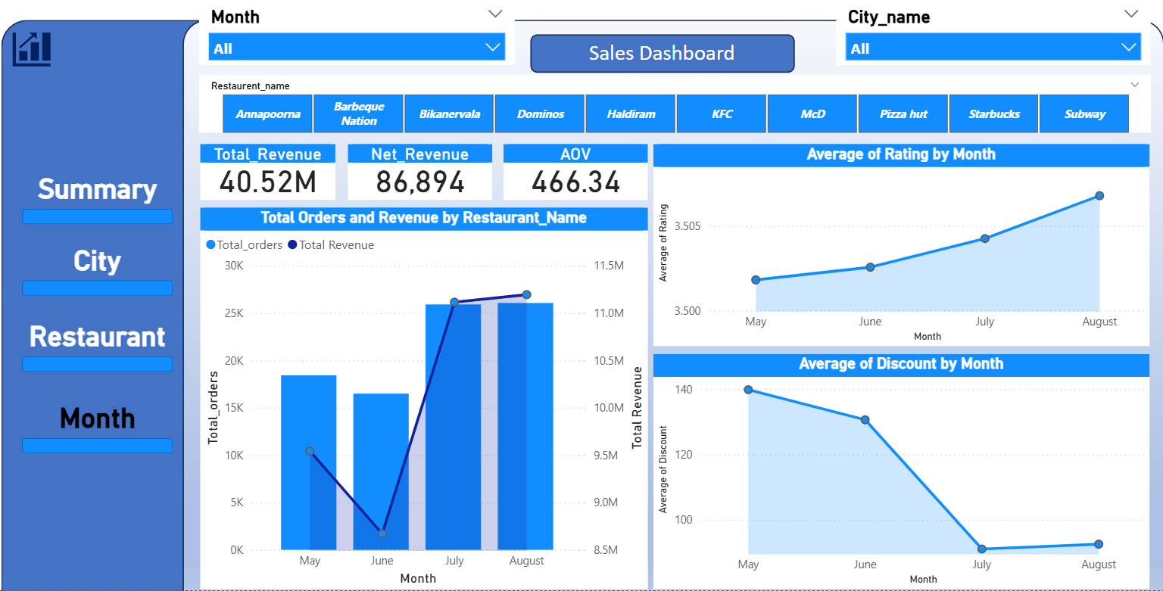

**City Wise Numbers**

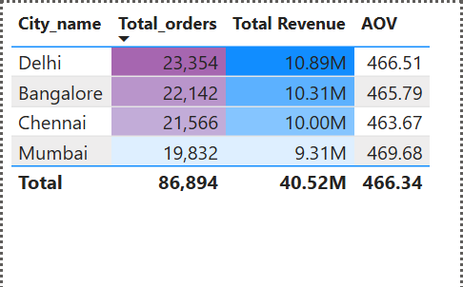

**Restaurant Wise Revenue%**

